***LIBERTY ELECTRONICS***

|  |  |  |
| --- | --- | --- |
| Supervisor | Miss Yumna Khalid | |
| Batch | *2505C1* | |
| Group | B | |
| Serial No. | Enrolment Number | Student Name |
| 3. | Students1659441 | Muhammad IBRAHIM |
| 4. | Students1597339 | Muhammad AHMED |
| 5. | Students1594032 | Muhammad RASHID |

*User guide*

1. Layout Tab

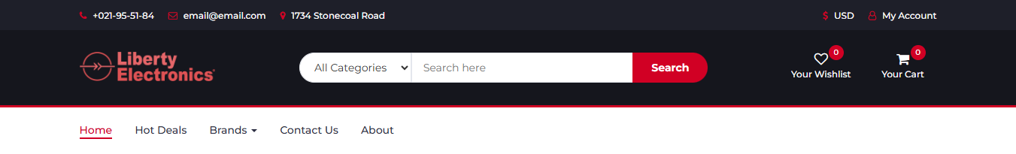

***Figure 1***

* Clicking on the other navigational links will lead to their respective webpages.

2. Layout Bottom

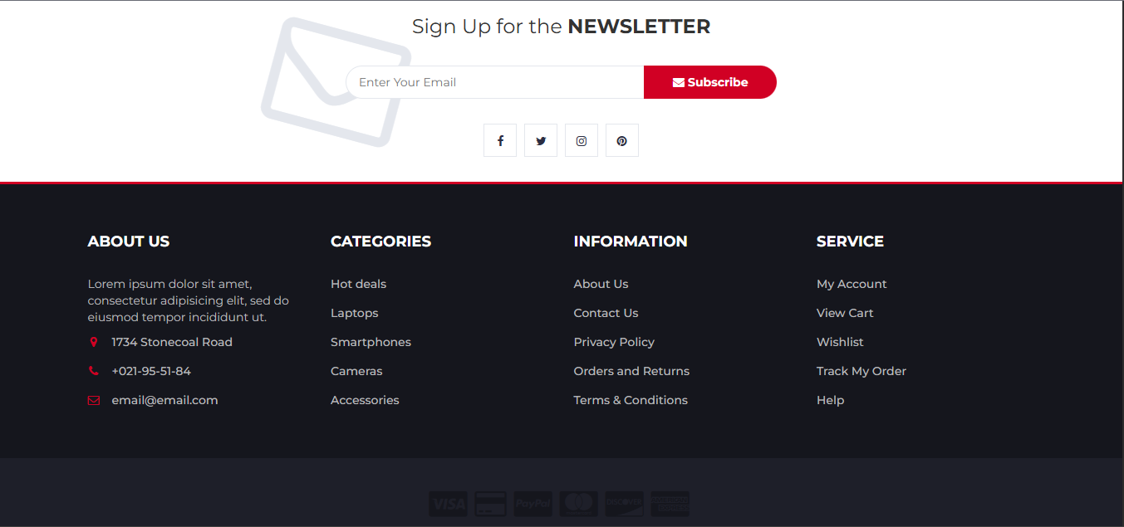

***Figure 2***

* Clicking on the navigational links will open to their respective webpages.
* The input field can be used to write email addresses, on which newsletters will be received.

1. Home Page

***Figure 3***

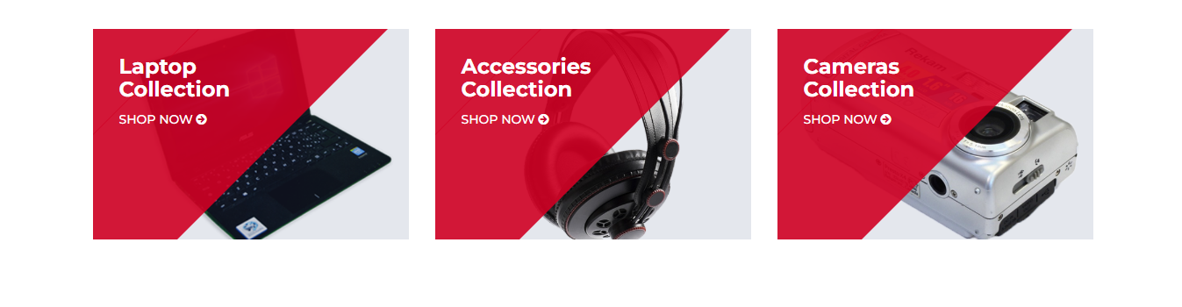

***Figure 4***

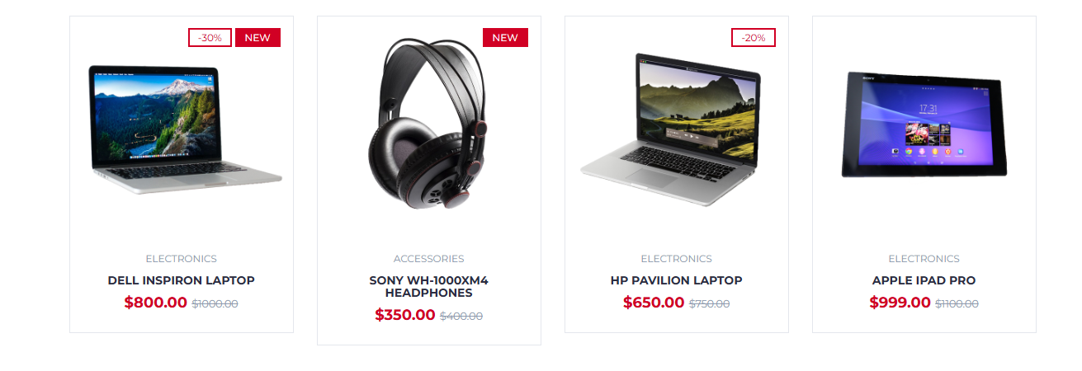

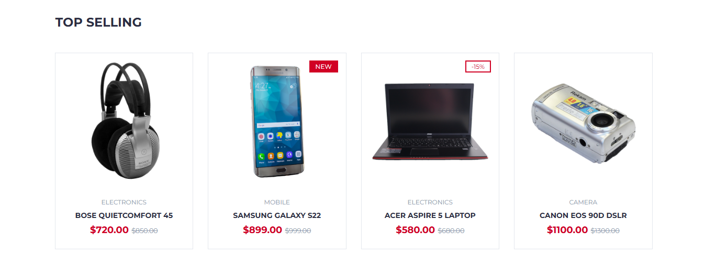***Figure 5***

* Hovering on the products will show a add to cart button, clicking on it will store it on your cart

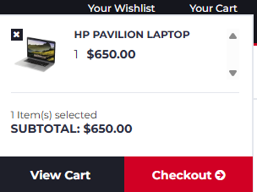

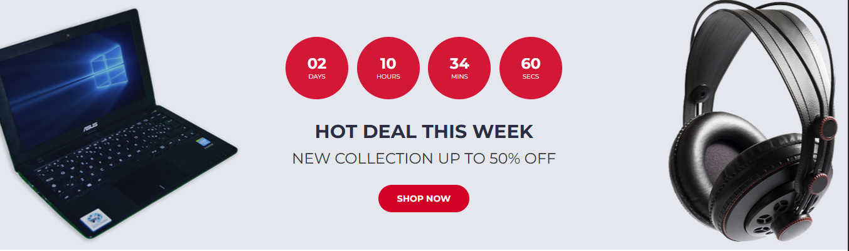

***Figure 6***

3. Your Cart



* After Adding Items To Your Cart you can click on “view your cart”:

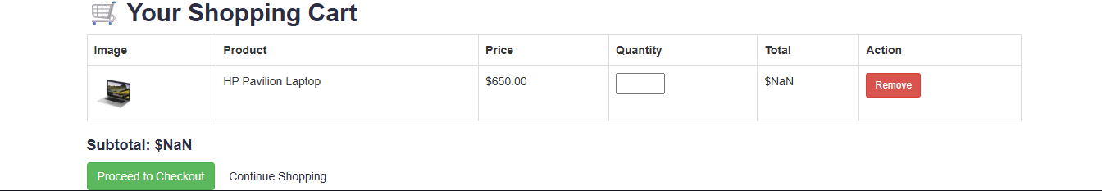

* Or you can also directly go to check out:

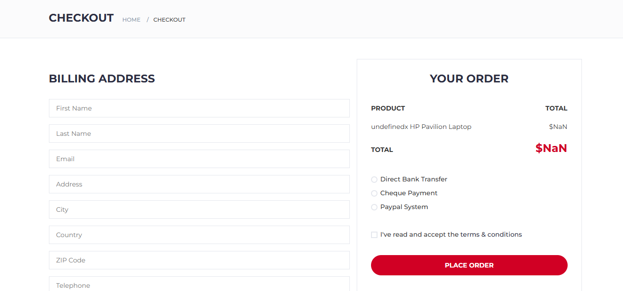

***Figure 8***

4. Brands

* + Apple
  + Samsung
  + Dell
  + Sony
  + HP



B

* By clicking this dropdown(Brand) you can select various brands:

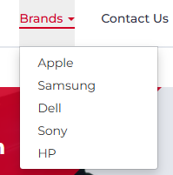

* If you go to one of the brands you can view their brands products which will filter and simplify your experience

APPLE:

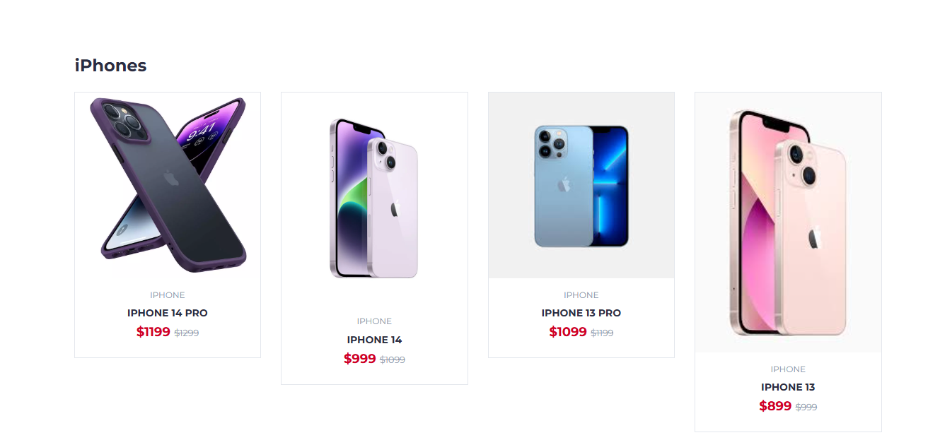

***Figure 7***

DELL:

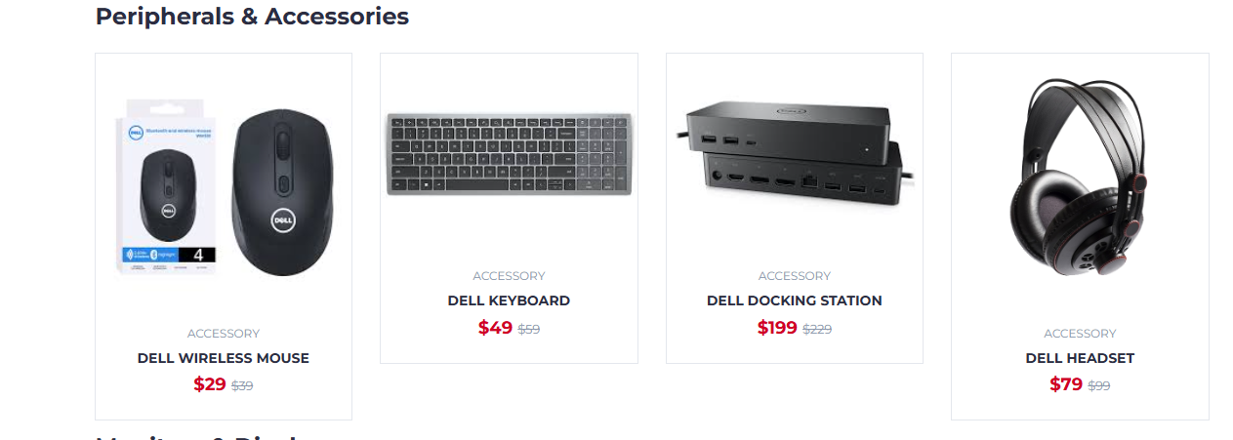

***Figure 8***

7. About Us

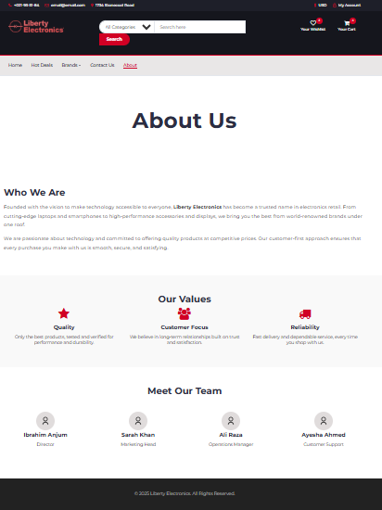

***Figure 9***

8. Contact Us

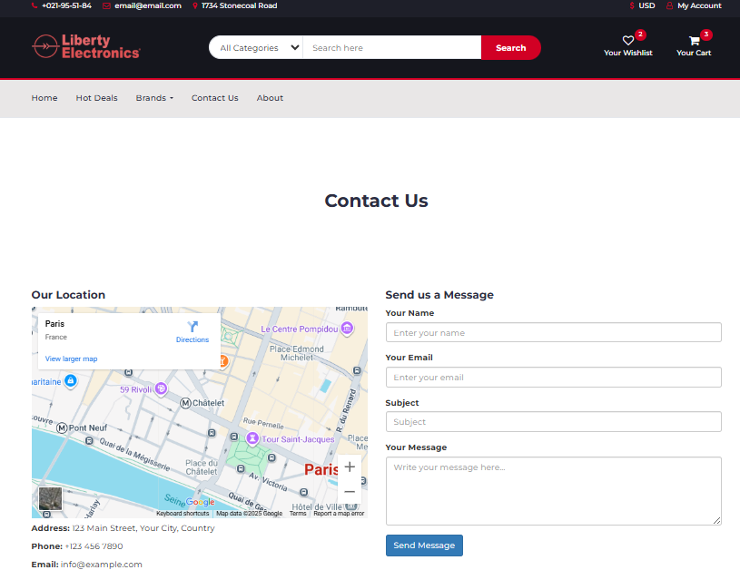

***Figure 10***